SIMATS ENGINEERING (SAVEETHA SCHOOL OF ENGINEERING)
Department of Computer Science and Engineering
CO2 ASSESSMENT TOOL 2 – ARCHITECTURE DESIGN ASSIGNMENT
Project: Crop Disease Detection and Farm Advisory Platform
Course Code: CSA10
Course Title: Software Engineering
CO Assessed: CO2
Student Name: HAASHINI P
Register Number: 192524047
Date: 31-10-2026
Code of Conduct
I Haashini P (192524047) certify that this submission is my original work and that I have adhered to the assessment guidelines. I understand that any violation of academic integrity rules may result in disciplinary action.
Signature of the Student:

1. Analyze System Requirements
1.1 System Objectives
The Crop Disease Detection and Farm Advisory Platform helps farmers identify possible crop diseases at an early stage by submitting photographs of affected plants. A machine-learning model analyzes the image and returns a possible disease result. The platform then presents relevant symptoms, prevention methods, and farm-care recommendations. It is intended as a decision-support tool and does not replace professional agricultural diagnosis.
- Allow farmers to register, sign in, and maintain basic farm details.
- Allow users to capture or upload crop images in supported formats.
- Validate uploaded images before sending them for analysis.
- Display a possible disease classification and confidence information when available.
- Provide crop-specific prevention methods and farm advisory guidance.
- Maintain a history of submitted images, results, and advisory information.
- Allow authorized experts or administrators to review cases and maintain advisory content.

1.2 Functional Requirements
FR-01 User registration and login: The system shall allow farmers and authorized staff to create accounts and sign in securely.
FR-02 Farmer profile: The system shall allow farmers to maintain basic profile information and optional farm details such as crop type and location.
FR-03 Image upload: The system shall allow a farmer to capture or upload a crop image in a supported format.
FR-04 Image validation: The system shall check file type, file size, and image availability before analysis.
FR-05 Disease detection: The system shall send a valid image to the configured machine-learning model and obtain a possible disease or healthy-crop classification for supported classes.
FR-06 Result display: The system shall display the predicted result, confidence or uncertainty information when available, and a notice that automated predictions may be incorrect.
FR-07 Farm advisory: The system shall retrieve relevant symptoms, prevention practices, and crop-care recommendations.
FR-08 Case history: The system shall allow authenticated farmers to view previous submissions, dates, results, and advisory details.
FR-09 Expert review: Where enabled, an agricultural expert shall review referred or uncertain cases and provide guidance.
FR-10 Feedback: The system shall allow farmers to submit feedback about the usefulness of the result and advisory.
FR-11 Content management: The administrator shall add, update, verify, or deactivate crop, disease, symptom, and advisory records.
FR-12 Notifications: If configured, the system may notify users when analysis is complete or an expert response is available.
FR-13 Error handling: The system shall display clear messages for invalid images, failed analysis, network errors, or unavailable services.

1.3 Non-Functional Requirements
Scalability: The system should support growth in users, image submissions, crop types, and disease classes by scaling application and analysis resources.
Maintainability: The system should separate user interface, business logic, model inference, and data management so components can be updated independently.
Reliability: The system should validate inputs, handle service failures, and preserve saved records when an analysis request fails.
Availability: The application and stored advisory information should remain accessible when required, subject to network and hosting availability.
Performance: Image upload, analysis, and result retrieval should complete within a reasonable time. A processing status should be displayed for longer requests.
Security: Authentication, role-based access, secure communication, and protected storage should prevent unauthorized access to profiles and case history.
Usability: The interface should use clear labels, simple navigation, readable text, and mobile-friendly screens.
Privacy: The platform should explain how images and farm details are used and collect only information needed for its functions.

1.4 Quality Attributes Influencing Architecture
Scalability, maintainability, reliability, availability, performance, and security are the main quality attributes. These attributes support the selection of a layered client-server architecture with a separate disease-detection service and structured data storage. Component separation makes the system easier to maintain, secure, and scale.

2. Select a Suitable Software Architecture
2.1 Selected Architecture – Layered Client-Server Architecture
A layered client-server architecture is selected. Farmers, agricultural experts, and administrators access the platform through a web or mobile client. Requests pass through the presentation layer to the application layer. The application layer communicates with the disease-detection service, application database, advisory knowledge base, and optional external services.

2.2 Architectural Layers
Presentation Layer: Provides screens for registration, login, image upload, disease results, advisory, case history, and administration.
Application / Business Layer: Implements authentication, role checking, input validation, case management, result handling, advisory selection, and communication between components.
Disease Detection Service: Preprocesses uploaded images and invokes the trained machine-learning model to return a possible disease classification.
Data Layer: Stores user accounts, farm details, image references, analysis results, case history, feedback, and administrative records.
Advisory Knowledge Base: Stores reviewed crop information, disease symptoms, prevention practices, and farm-care recommendations.
External Integration Layer: Optionally connects to weather services and email or SMS providers through APIs.

2.3 Justification
This architecture is suitable because the system has identifiable user-interface, business-processing, machine-learning, and data-management responsibilities. Farmers can access the application from different devices without directly accessing the database or model. The application layer controls requests and permissions, while the disease-detection service can be maintained or upgraded separately. It is easier to implement for an academic project than a large microservices system, while still allowing important services to be separated.
If image analysis becomes a processing bottleneck, the disease-detection service can be deployed on a more powerful machine or scaled separately. New crops, disease categories, advisory records, and external integrations can be added without redesigning the complete application.

3. Draw the Software Architecture Diagram
Figure 1 shows the proposed architecture. Farmers and agricultural experts use a web or mobile client, while administrators use an authorized browser interface. Both communicate securely with the presentation layer. The application layer validates requests and coordinates image analysis, database operations, and advisory retrieval.
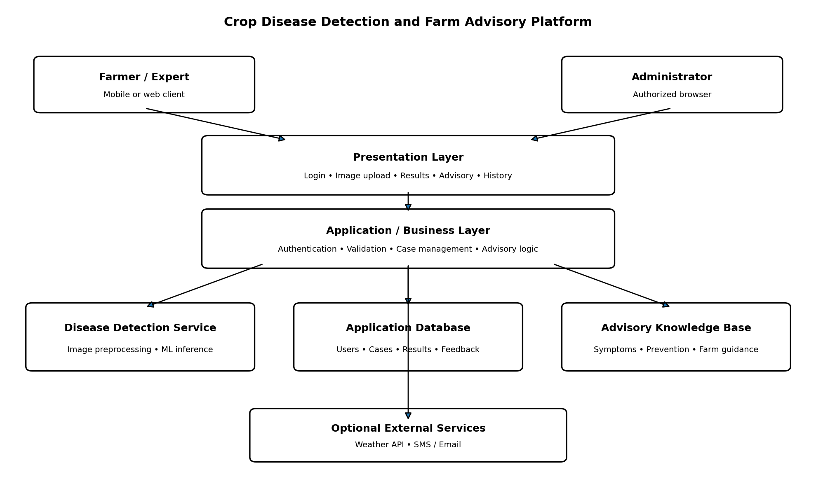
Figure 1: Layered client-server architecture for the Crop Disease Detection and Farm Advisory Platform.
The main communication path is user interface → application layer → disease-detection service and data stores → application layer → result and advisory displayed to the user. HTTPS is used for client-server communication, while internal APIs connect the application to the model service and other components.

4. Explain Components and Their Interactions
4.1 Component Responsibilities
Farmer / Expert Client: Allows users to sign in, submit images, view results, read advice, review history, and provide feedback. Experts can access referred cases when enabled.
Administrator Client: Allows authorized administrators to manage accounts, crop and disease records, and advisory information.
Presentation Layer: Receives user actions, displays forms and results, and sends requests to the application layer through secure API calls.
Authentication and User Management: Verifies credentials, manages sessions, and checks user roles before allowing access to protected functions.
Image Upload and Validation: Accepts the selected image, checks its format and size, and rejects invalid files with a clear message.
Disease Detection Service: Preprocesses a valid image and passes it to the trained model. It returns the predicted class and confidence information when available.
Advisory Service: Uses crop and predicted disease information to retrieve symptoms, prevention steps, and farm-care recommendations.
Application Database: Stores user profiles, farm details, case records, image references, analysis results, feedback, and audit information.
Advisory Knowledge Base: Maintains reviewed information about crops, diseases, symptoms, and recommended practices.
External Services: Optional weather and notification APIs provide additional information or alerts when configured.

4.2 Component Communication
The client communicates with the presentation layer over HTTPS. The presentation layer sends requests to the application layer through APIs. The application layer checks identity and permissions, validates the submitted image, and stores case details. It sends the valid image or a secure image reference to the disease-detection service. The model returns a prediction, which the application stores in the database. The advisory service retrieves relevant guidance from the knowledge base. Finally, the application sends the result and advisory to the presentation layer for display.

4.3 Overall System Workflow
- The farmer opens the application and registers or signs in.
- The farmer selects a crop image and submits it for analysis.
- The application validates the image format, size, and availability.
- The application sends the valid image to the disease-detection service.
- The machine-learning model analyzes the image and returns a possible disease classification.
- The application stores the result and retrieves matching advisory information.
- The farmer views the possible result, symptoms, prevention steps, and recommended next actions.
- The farmer may save the case, provide feedback, or request expert review if available.

5. Discuss Quality Attributes
5.1 Scalability: The presentation and application layers can be given additional capacity as traffic increases. The disease-detection service can be scaled separately because image inference may require more processing resources. Image storage can be expanded as submissions grow.
5.2 Security: The system uses authenticated access and role-based permissions for farmers, experts, and administrators. HTTPS protects data during transmission. Passwords should be stored using secure password hashing, and database access should be restricted to authorized application components. Farmers should only view their own private case history.
5.3 Performance: Image validation occurs before model inference to avoid unnecessary processing. The model service is separated from ordinary application functions so image analysis can be optimized independently. The interface should show a processing indicator when analysis takes time.
5.4 Reliability: The application checks uploaded files and handles failures from the model service, database, or network. Failed analysis should return a clear error rather than a false disease result. Case details should be saved safely.
5.5 Maintainability: The layered design separates the user interface, business rules, model inference, and data management. Developers can update the model, advisory content, or interface with limited changes to other components. Documented APIs support controlled integration.
5.6 Availability: The platform should use reliable hosting, database backups, and monitoring. If the model service is temporarily unavailable, users should still be able to view previous cases and advisory content, while new analysis is marked unavailable.

6. Justify Architectural Decisions
6.1 Rationale Behind the Design
The layered client-server architecture provides clear separation of responsibilities and suits a system accessed by farmers, experts, and administrators through web or mobile devices. It centralizes authentication, validation, and business rules in the application layer. The separate disease-detection service allows the machine-learning model to be developed, tested, and upgraded without changing the complete application. Dedicated data stores keep user and case information organized and make advisory content easier to maintain.

6.2 Trade-Offs Considered
Advantages: The design is straightforward to understand, test, and implement. It supports centralized security and data management. The model-inference component can be scaled or replaced independently, and the architecture supports future API integrations.
Limitations: The application layer can become a bottleneck if all requests pass through one server. The system depends on network connectivity for online image analysis. Separate model and data services add deployment and monitoring work.
Reason for not selecting full microservices: Microservices provide independent deployment for many services, but add infrastructure, communication, and operational complexity. For this academic project, a layered design with a separately deployable model service offers a more practical balance.

6.3 Future Enhancements and Long-Term Maintenance
- Add more crop types, disease classes, and regional languages after suitable data and model validation.
- Integrate weather information through a trusted weather API for context-aware advisory where appropriate.
- Add notifications for completed analysis, expert responses, or important advisory updates.
- Provide offline-friendly features or low-bandwidth image upload for farmers with limited connectivity.
- Improve model performance using reviewed field images and periodic evaluation under different lighting and crop conditions.
- Add expert feedback to review uncertain predictions and improve advisory quality.
- Maintain versioned models, advisory records, and API documentation for safe updates.

Conclusion
The proposed Crop Disease Detection and Farm Advisory Platform uses a layered client-server architecture with a separate disease-detection service, application database, and advisory knowledge base. This design addresses the main functional requirements and the quality attributes of scalability, security, performance, reliability, maintainability, and availability. It is practical for the project and flexible enough to support future crops, model improvements, and external integrations. Automated disease results should be presented as preliminary decision support and not as a guaranteed diagnosis.

